Alpha - Version
Requirements Gathering Template

Project Overview

Project Manager: Bhekabona Mbhele
Project: Chemical Analysis System
Plant: High Chrome Ball Plant
Version: 4.2.0.1
Prepared by: Tsundzukani Nkuna
From Date: 2025/ 05/ 26 To Date: 2025/ 05/ 29
Project Objectives: The objective of the project is to automate and streamline the management, analysis, and reporting of chemical composition data in the High Chrome Ball Plant to enhance quality control, decision-making, and operational efficiency.

Business Requirements
Business Goals:
The Chemical Analysis System for the High Chrome Ball Plant is developed to automate the collection, analysis, storage, and presentation of chemical composition data from furnace-extracted Molds. The system aims to:
- Enhance Communication: Facilitate clear and timely interaction among Operators, Technicians, Engineers, and Metallurgists by providing centralized, accessible chemical data.
- Support Data-Driven Decisions: Provide accurate, real-time insights into chemical compositions, empowering teams to make informed decisions regarding production quality and process adjustments.
- Enable Data Export: Allow users to export displayed analysis results in XLSX and PDF formats for accurate record-keeping, and historical comparison.
- Improve Operational Efficiency: Replace manual reporting and spreadsheets with an automated, user-friendly interface that streamlines analysis, communication, and decision-making processes.

Business Rules
The following business rules and constraints govern the functionality, access, and operational logic of the Chemical Analysis System:
1. Data Integrity & Validation
- Only validated chemical results (from lab equipment or authorized personnel) may be stored in the system.
- Duplicate entries for the same Mold, date, and time are not allowed.
- The system must reject any chemical value that exceeds predefined physical or process-based limits.
2. Access & Permissions
- Role-based access control must be enforced:
- Operators can view and export data only.
- Technicians can upload, edit, and annotate results before final validation.
- Metallurgists can approve or reject results and provide feedback.
- Engineers have read-only access to trend data and reports.
- Only authorized users may export data to XLSX or PDF formats.
3. Time & Date Constraints
- Chemical analysis records must include both date and time stamps for traceability.
- Entries older than 90 days may be archived but not deleted, unless explicitly authorized.
5. System Availability
- The system must be accessible during standard plant operating hours (24/7), with scheduled downtime communicated 24 hours in advance.
- Automatic backups of all chemical analysis data must occur every 6 hours.
6. Performance & Responsiveness
- The system should retrieve and display query results within 3 seconds for normal data ranges.
- Charts must reflect updated data within 15 seconds of new entry upload.

Functional Requirements
Use Cases and User Stories
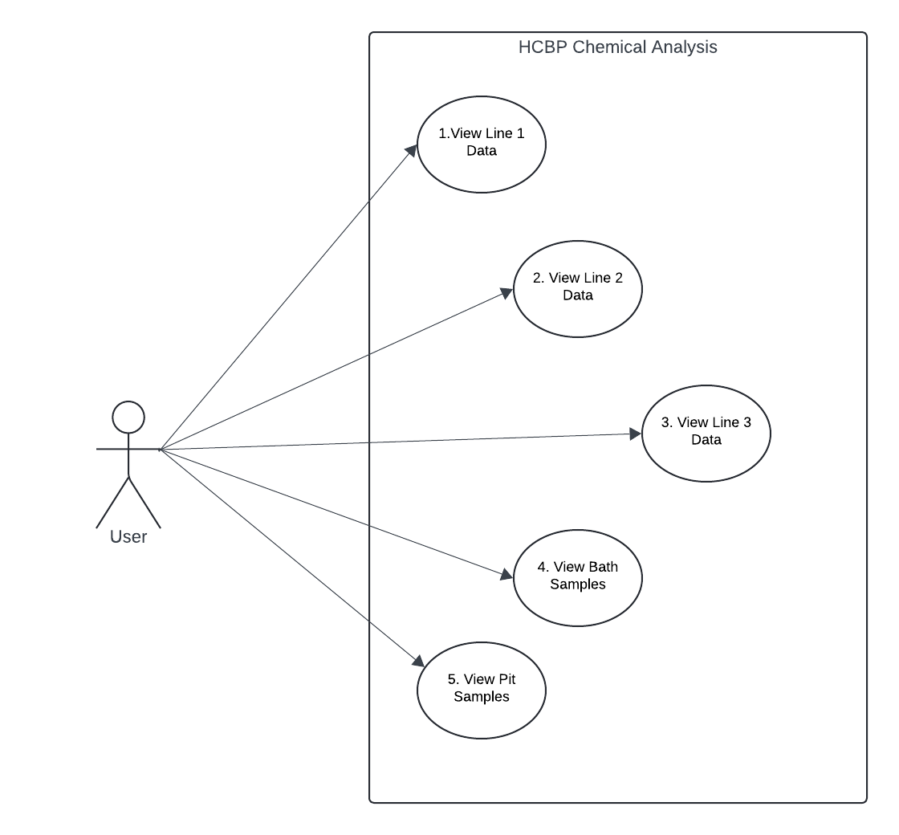
Use Case 1: View Line 1 Data
As a User,
I want to view the latest chemical analysis results from Molds used in Line 1,
So that I can monitor production quality in real time.
Use Case 2: View Line 2 Data
As a User,
I want to view the latest chemical analysis results from Molds used in Line 2,
So that I can monitor production quality in real time.
Use Case 3: View Line 3 Data
As a User,
I want to view the latest chemical analysis results from Molds used in Line 3,
So that I can monitor production quality in real time.
Use Case 4: View Bath Samples Data
As a User,
I want to view the latest chemical analysis results from Molds used in Bath Samples,
So that I can monitor production quality in real time.
Use Case 5: View Pit2 Samples Data
As a User,
I want to view the latest chemical analysis results from Molds used in Pit2 Samples,
So that I can monitor production quality in real time.

System Cases and System Stories
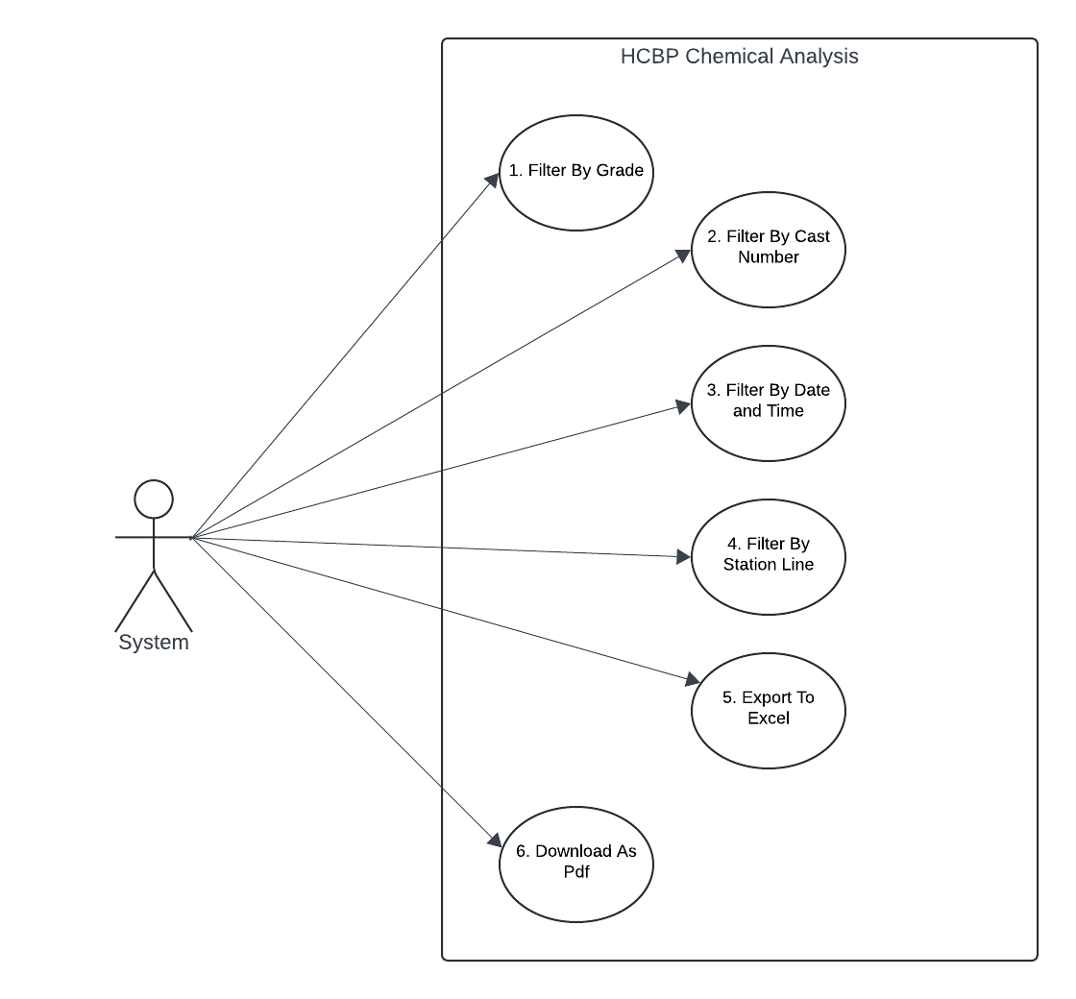
System Case 1: Filter By Grade
As a System,
it should allow to filter chemical data by grade Search,
So that a user can quickly locate specific grade entries for validation or export.
System Case 2: Filter By Cast Number
As a System,
it should allow to filter chemical data by Cast Number Search,
So that a user can quickly locate specific Cast Number entries for validation or export.
System Case 3: Filter By Date and Time
As a System,
it should allow to filter chemical data by Date and Time,
So that a user can quickly locate specific Date and Time entries for validation or export.
System Case 4: Filter By Station Line
As a System,
it should allow to filter chemical data by Station Line either Line 1, Line 2 or Line 3,
So that a user can quickly locate specific Lines entries for validation or export.
System Case 4: Export To Excel
As a System,
it should allow to export chemical data results to xlsx,
So that a user can quickly document and share chemical data for review and compliance.
System Case 4: Download to Pdf
As a System,
it should allow to download chemical data results to pdf,
So that a user can quickly document and share chemical data for review and compliance.

System Features
Feature 1: Filter by Grade
- Description: The system allows users to filter chemical analysis records based on the Grade of the material.
- Purpose: To enable fast retrieval of grade-specific data for validation or export.
- Inputs: Grade input from a search box.
- Output: Filtered data grid with only records matching the specified grade.

Feature 2: Filter by Cast Number
- Description: The system enables filtering of chemical analysis data based on the Cast Number.
- Purpose: To allow users to find and review data tied to a specific production cast.
- Inputs: Cast Number entered by the user.
- Output: Results showing only matching Cast Numbers.

Feature 3: Filter by Date and Time
- Description: The system provides filtering capabilities by Date and Time ranges.
- Purpose: To allow users to retrieve historical or time-specific data entries.
- Inputs: Start and end date/time values.
- Output: Filtered chemical analysis records that fall within the specified time window.

Feature 4: Filter by Station Line
- Description: The system allows users to filter chemical data by Station Line (e.g., Line 1, Line 2, Line 3).
- Purpose: To focus the analysis or review process on a specific furnace line.
- Inputs: Selected line from a dropdown or filter option.
- Output: Records related to the selected line only.

Feature 5: Export to Excel
- Description: The system supports exporting filtered or full chemical analysis data to Excel (.xlsx) format.
- Purpose: To facilitate easy sharing, archiving, or further offline analysis.
- Trigger: Clicking the “Export to Excel” button.
- Output: Downloadable .xlsx file with chemical records and applied filters.

Feature 6: Download to PDF
- Description: The system allows users to download displayed chemical data as a PDF document.
- Purpose: To support printable, standardized reporting and sharing of analysis results.
- Trigger: Clicking the “Download as PDF” button.
- Output: Downloadable .pdf file containing filtered chemical data and header information (date, grade, cast number, etc.).

Data Requirements:
Data Input
The following data will be provided to the system from either user input or automated data feeds:
- Chemical Composition Values (e.g., Al, C, Cr, Cu, Mn, Mo, N, Ni, P, S, Fe)
- Sample Metadata:
  - Cast Number
  - Grade
  - Sample Type (Bath, Pit)
  - Sample Type Number
  - Operator Name
  - Date and Time of Sampling
- User Inputs for Filtering and Search:
  - Grade
  - Cast Number
  - Date and Time range
  - Station Line selection
- Manual Entry or Automated Sync from Lab Equipment or GM-Reportee System
Data Output
The system will produce and display the following output data:
- Filtered Chemical Analysis Results based on user-specified criteria
- Tabular Results displayed in a web-based grid (e.g., Grid View)
- Exportable Files:
  - XLSX files for full or filtered datasets
  - PDF files with chemical results, headers, and timestamped metadata
- Trend Charts and Graphs visualizing chemical element behaviour over time

Data Storage
- Primary Storage: SQL Server Database (GM-Reportee)
  - Table: Line1_New (and similar tables for Line 2, Line 3, Bath, Pit)
- Backup Policy:
  - Automatic backup of the database every 1 Month
- Security & Integrity:
  - All data is access-controlled via role-based permissions.
  - Input is validated to prevent malformed or out-of-bound entries.

Technical Requirements
Platform
- The system will run on:
  - Microsoft Windows Server (IIS-hosted web application)
  - SQL Server for database backend
  - Accessible via modern web browsers (Chrome, Edge, Firefox)
Technology Stack
- Backend: ASP.NET (Web Forms or MVC) with C#
- Frontend: HTML, CSS, JavaScript, ASP.NET Web Controls
- Database: Microsoft SQL Server
Integration
- GM-Reportee System: For real-time and historical data access.
- Laboratory Equipment (Optional Future Phase): Direct data ingestion from analysis machines.

Non-Functional Requirements
Performance
- The system must load filtered data queries within 15 seconds.
- The system must support concurrent access by at least 50 users without performance degradation.
- Chart rendering and export functions (XLSX/PDF) must complete within 5 seconds under normal load.
Security
- Data Transmission: All data transmitted between client and server must be secured via HTTPS.
- Access Control: Granular permissions by role (e.g., only Metallurgists can verify/reject samples).
- Data Protection: Stored data must be protected against unauthorized access, tampering, or deletion.
Scalability
- The system should be designed to scale horizontally with minimal configuration changes.
- Support for future data growth, including:
  - More station lines (beyond Line 1, 2, and 3)
  - Additional sample types or plants
Availability
- The system must be available at least 99.5% of the time during business hours (24/7 preferred for plants running continuously).
- Database and application services should be backed up with a disaster recovery plan.

User Requirements
Role 1: Operator
- Description: Operators are responsible for entering or verifying real-time chemical analysis data from samples extracted at the furnace.
- Responsibilities:
  - Enter cast numbers and sample metadata.
  - View chemical analysis results.
  - Filter results by line, date, or grade.
  - Export results to Excel or PDF for recordkeeping.
Role 2: Technician
- Description: Technicians ensure the accuracy and completeness of the chemical data entered the system.
- Responsibilities:
  - Validate analysis results before submission.
  - Generate reports for process or quality engineers.
  - Use filtering tools for reviewing past samples.
  - Upload or correct missing sample data.

Role 3: Metallurgist
- Description: Metallurgists analyse the chemical data to assess quality, process trends, and determine corrective actions if necessary.
- Responsibilities:
  - Review chemical compositions and trends.
  - Verify and approve/reject specific sample entries.
  - Provide expert feedback or corrective notes.
  - Use trend charts and export data for deeper analysis.

Role 4: Engineer
- Description: Engineers analyse data over time to ensure process consistency and product conformity.
- Responsibilities:
  - Monitor statistical trends of elements.
  - Use data for production improvement and reporting.
  - Compare performance across different lines.

Role 5: System Administrator
- Description: Admins manage user accounts, system configurations, backups, and security policies.
- Responsibilities:
  - Manage user roles and permissions.
  - Ensure database connectivity and backup health.
  - Oversee system updates or integration changes.

User Interface (UI) Requirements
- Responsive Design: The web interface must be usable on desktop.
- Intuitive Layout: Clear navigation with minimal clicks to access key functions.
- Search & Filter Panel: Prominent and easily accessible filters (Grade, Cast No, Date Range, Line).
- Table Format: Display chemical results in a structured, sortable table.
- Export Buttons: Clearly labelled options for "Export to Excel" and "Download PDF".
- Chart Visualization: View historical trends via line charts.

Usability Requirements
- Minimal Training: The system should be easy to use with little to no training required for basic functions.
- Fast Load Times: Data should display within 2 seconds for common filters.
- Accessibility: Ensure readability (font size, contrast) and proper tab order for keyboard navigation.
- Error Handling: User-friendly error messages for invalid inputs or connection issues.
- Consistency: Uniform design and behaviour across all pages and features.

Reporting & Analytics
Reports Needed
- Daily Chemical Analysis Report
Summary of all samples analysed each day, categorized by Line and Grade.
- Shift-Based Sample Report
Analysis data grouped by operator shift (Morning, Afternoon, Night).
- Grade-Wise Composition Report
Aggregated chemical element data grouped by product grade.
- Rejection/Non-Conformity Report
Reports listing samples outside specified chemical tolerance.
Data Visualization
- Scatter Plots
Optional: for visualizing correlation between multiple elements.
Analytics Tools
- Built-In Filters & Search (by Date, Grade, Cast No., etc.)
- Export to Excel/PDF for offline analysis
- SQL Queries / Views for advanced reporting
Constraints
Timeline
- Development Start: 18 April 2025
- Testing Phase: Frequently after Updates
- Go-Live: Frequently after Updates approval
Resources
- Team:
  - MIS Technician
- Technology:
  - Windows Server with IIS
  - SQL Server
  - ASP.NET stack
Other Constraints
- The system must operate without internet access / under Automation Services Network due to network policies.
- Must support legacy lab equipment outputs (e.g., .CSV files).

Assumptions
- SQL Server and IIS hosting are already set up and configured.
- Plant staff will be available for feedback during UAT.
- The reporting needs will remain relatively stable post-launch.
- Users have basic computer literacy and can operate Excel and PDF tools.

Risks
Identified Risks
- Incomplete or inconsistent data from lab equipment.
- Resistance to change from manual/spreadsheet methods.
- Downtime of GM-Reportee affecting data access.
- Unexpected data volume growth impacting performance.
Risk Mitigation Strategies
- Implement validation rules to catch and flag incomplete data.
- Conduct user training and demos to ease adoption.
- Design the system with offline caching fallback (if needed).
- Optimize queries and prepare archiving strategies for old data.

11. Approval & Sign-Off
Stakeholder Sign-Off:

Name: [Stakeholder name]

Signature: [Signature or approval]

Date: [Date of approval]

